**ONLINE AUCTION PLATFORM**

REPORT ON DATABASE MANAGEMENT SYSTEM PROJECT



**INSTITUTE OF ENGINEERING & MANAGEMENT**

# SALT LAKE, KOLKATA

# SUBMITTED BY:

# TANNISTHA NEOGY

# ENROLLMENT NUMBER:12021002016066

# SHIRSA MONDAL

# ENROLLMENT NUMBER:12021002016072

# ACKNOWLEDGEMENT:

# We extend our sincere gratitude to our project guide, for their invaluable guidance and support. We also thank the faculty of [CSE(AIML)] for creating an enriching academic environment. Our appreciation goes to our peers for their collaborative efforts. Additionally, we are grateful to our family for their unwavering encouragement. This project wouldn't have been possible without their collective contributions.

# [Shirsa Mondal]

# [Tannistha Neogy]

# [CSE(AIML)]

# [Institute of Engineering & Management]

# [16.10.23]

**CONTENTS:**

# 1 Introduction. . . . . . . . . . . . . . . . . . . . . . . . . . . . 4

# 1.1 Challenges . . . . . . . . . . . . . . . . . . . . . . . . . . . . 4

# 1.2 Motivation . . . . . . . . . . . . . . . . . . . . . . . . . . . . 6

# 1.3 Organization of the report . . . . . . . . . . . . . . . 7

# 2 Project Proposal. . . . . . . . . . . . . . . . . . . . . . . . . . 7

# 2.1 Problem Statement . . . . . . . . . . . . . . . . . . . . . . 7

# 2.2 Proposed Model . . . . . . . . . . . . . . . . . . . . . . . . . 7

# 2.3 Plan of Execution . . . . . . . . . . . . . . . . . . . . . . . . 7

# 2.4 Project Timeline . . . . . . . . . . . . . . . . . . . . . . . . . 8

# 

# 3 Diagrams. . . . . . . . . . . . . . . . . . . . . . . . . . . . . . . 10

# 3.1 ER Diagram. . . . . . . . . . . . . . . . . . . . . . . . . . . . 10

# 3.2 DFD 0-Level. . . . . . . . . . . . . . . . . . . . . . . . . . . . 11

# 3.3 DFD 1-Level. . . . . . . . . . . . . . . . . . . . . . . . . . . . 12

# 4 Experimentation . . . . . . . . . . . . . . . . . . . . . . . . . . . 13

# 4.1 Preliminary studies . . . . . . . . . . . . . . . . . . . . . . . 13

# 4.2 Results and Analysis . . . . . . . . . . . . . . . . . . . . . . 14

# 5 Conclusion. . . . . . . . . . . . . . . . . . . . . . . . . . . . . . . . .16

# 5.1 Inference . . . . . . . . . . . . . . . . . . . . . . . . . . . . . . . . 16

# 5.2 Future Scope . . . . . . . . . . . . . . . . . . . . . . . . . . . . . 17

# INTRODUCTION:

# An online auction platform is a digital marketplace where individuals and businesses can buy and sell a wide variety of items through an auction-style format. These platforms leverage the power of the internet to facilitate the bidding process, enabling participants from all over the world to engage in buying and selling goods. Here are some key features and aspects of online auction platforms:

# 🡪Bidding System

# 🡪Seller Listings

# 🡪Auction Durations

# 🡪Reserve Prices

# 🡪Categories

# 🡪Payment and Shipping

# 🡪Real-time Bidding

# In the dynamic landscape of e-commerce, where convenience and choice are paramount, we present "BabyCorp" – your one-stop destination for all things baby-related. Our online web application is dedicated to simplifying the lives of parents, caregivers, and anyone seeking the best for their little ones.

# This project report delves into the concept, development, and potential impact of BabyCorp, an innovative web application that has been meticulously designed to serve the ever-evolving needs of those caring for infants and toddlers. From an array of cozy clothing and nursery essentials to innovative gadgets and feeding solutions, BabyCorp offers a thoughtfully curated selection of baby items that cater to both practicality and comfort.

# CHALLENGES:

# Building an online auction platform for baby products, like any e-commerce venture, comes with its set of challenges. Here are some of the key challenges you might face:

# 1.Security and Trust: Ensuring the security of both buyers and sellers is paramount. You'll need to implement robust authentication and authorization systems to protect user data and financial transactions. Building trust within your platform is critical to attract users.

# 2.Regulatory Compliance: The sale of baby products often falls under strict regulatory requirements, including safety standards and labeling. Complying with these regulations can be complex and varies by region.

# 3.Quality Control: Since baby products directly affect the well-being of infants, ensuring the quality and safety of items listed on your platform is crucial.You may need a stringent vetting process for sellers to verify the authenticity and safety of products.

# 4.User Verification: Verifying the identity of users and conducting background checks on sellers can be challenging, as it requires resources and thorough processes.

# 5.User Privacy: You must handle user data with care, especially considering the sensitivity of personal information related to children. Compliance with data protection laws is essential.

# 6.Scalability: As your platform grows, handling increased traffic and transactions becomes more complex. Scalability is a significant challenge to ensure the platform remains responsive and available.

# 7.Mobile Responsiveness: Many users access e-commerce platforms through mobile devices. Ensuring a seamless mobile experience is vital, requiring responsive design and app development.

# 8.Payment Processing: Integrating secure payment gateways and managing financial transactions can be complex and necessitates strong encryption and fraud detection mechanisms.

# 9.User Experience: Creating an intuitive and user-friendly platform that makes it easy for users to browse, bid on, and purchase products is a substantial challenge. This includes optimizing search functionality and streamlining the bidding process.

# 10.Competitive Marketplace: The e-commerce space is highly competitive. Standing out in the market and attracting sellers and buyers will be challenging.

# 11.Customer Support: Providing effective customer support to address user inquiries, concerns, and disputes is crucial. This requires a dedicated support team and well-defined processes.

# 12.Marketing and Promotion: Building a customer base and creating brand awareness is a challenge. You'll need effective marketing strategies to attract both buyers and sellers.

# 13.Trust and Reputation: Establishing your platform as a trustworthy and reputable place for baby products is an ongoing challenge. Negative experiences can harm your reputation quickly.

# 14.Product Diversity: Maintaining a diverse and comprehensive range of baby products on the platform can be difficult, as you'll need to attract various sellers.

# 15.Technology Infrastructure: Building and maintaining a robust technological infrastructure that can handle large volumes of data, images, and user interactions is another challenge. This includes server capacity and load balancing.

# Overcoming these challenges requires careful planning, continuous improvement, and a strong commitment to ensuring the safety, security, and satisfaction of your users. It's important to stay updated on industry standards, regulations, and best practices to navigate these challenges effectively.

# MOTIVATION:

# The motivation to create "BabyCorp" is deeply rooted in a genuine concern for the well-being of parents, caregivers, and, most importantly, the precious babies who depend on them. We recognize the challenges that come with parenting, and the desire to ease this journey propels our project.First and foremost, our goal is to empower parents by providing them with a convenient and reliable platform for procuring essential baby products. We understand that parenting is a demanding job, and we aim to simplify the process of acquiring quality items through BabyCorp, saving parents valuable time and effort.Ensuring the safety and quality of products is not just a priority; it's our unwavering commitment. We're motivated by the knowledge that every product listed on our platform meets the highest safety and quality standards, assuaging the concerns of parents about the products they purchase for their children.Moreover, building trust within our community is at the core of our motivation. We envision BabyCorp as a platform where users feel confident in their purchases, knowing they are sourcing items from trustworthy sellers who share our dedication to excellence.By creating an innovative and user-centric e-commerce platform, we strive to push the boundaries of what's possible in the baby product industry. We're excited to harness technology to deliver a unique and inspiring online shopping experience that caters to the diverse needs of parents and caregivers.Supporting small businesses and entrepreneurs is also a source of motivation. BabyCorp is not only a platform for established retailers but also a springboard for emerging entrepreneurs in the baby product industry. We're inspired by the potential to foster an inclusive marketplace where small businesses can flourish and connect with a broader audience.Furthermore, we're motivated to create a community of caregivers who can share experiences, advice, and recommendations. Beyond transactions, we envision BabyCorp as a space where parents come together to support one another through the beautiful, albeit challenging, journey of parenthood.Identifying market gaps and addressing them is another compelling force behind our project. Through thorough market research, we've recognized a need for a dedicated platform that exclusively caters to baby products. BabyCorp fills this gap by offering a comprehensive range of carefully curated items, specifically tailored to the needs of parents and their infants.The motivation also lies in our commitment to continuous improvement and innovation. We aspire to evolve with the needs of our users, incorporating feedback and embracing emerging technologies to enhance the BabyCorp experience continually.Ultimately, the most profound source of motivation comes from knowing that BabyCorp plays a role in ensuring that infants and toddlers are provided with the best possible start in life. It's a project fueled by the belief that every child deserves the highest standard of care and comfort, and the satisfaction of contributing to the well-being of the next generation is immeasurable.

# ORGANIZATION OF THE REPORT:

# Introduction

# Project Proposal

# Diagrams

# Experimentation

# Conclusion

# 2. PROJECT PROPOSAL:

# 2.1 Problem Statement :

# To make an online auction platform

# 2.2 Proposed Model :

# A BabyCare centric auction web application platform

# 2.3 Plan of Execution :

# Creating an online auction platform for baby products like "BabyCorp" involves several essential steps. Below is a high-level plan of execution to guide you through the process:

# Conceptualization and Research:Define the project's goals, vision, and scope.

# Conduct market research to understand the demand for such a platform.

# Identify competitors and their strengths and weaknesses.

# Business Plan:Create a detailed business plan outlining your business model, revenue sources, and financial projections.Determine the legal structure of your company and fulfill any necessary legal requirements.

# Platform Design and Development:Design the user interface (UI) for the website or app, focusing on a user-friendly and attractive design.

# Develop the platform, including the front-end (user interface) and back-end (server and database).Implement features like user registration, product listing, bidding, payment processing, and security measures.

# Quality Assurance:Conduct thorough testing to ensure the platform is secure and free of bugs or issues.Test the website or app on various devices and browsers to ensure compatibility.

# Legal and Compliance:Ensure compliance with local and international regulations, particularly those related to the sale of baby products.

# Draft user agreements, terms of service, and privacy policies.

# Product Curation and Onboarding:Establish a process for onboarding sellers, including verification and quality checks.Develop guidelines for product listings and ensure compliance with safety standards.

# Marketing and Branding:Create a brand identity and a marketing strategy to promote your platform.Use various marketing channels, including social media, email marketing, and search engine optimization (SEO), to attract users.

# User Support and Community Building:Set up customer support to address user inquiries and concerns.Foster a community of users by encouraging engagement and providing educational content.

# Launch:Conduct a soft launch or beta testing phase to gather user feedback.

# Make necessary improvements based on feedback.Plan a formal launch to the public.

# Scaling and Growth:Continuously monitor the platform's performance, user engagement, and sales.Scale your platform by adding new features, expanding the product range, and reaching out to a broader audience.

# Security and Privacy:Regularly update and strengthen security measures to protect user data and transactions.Ensure compliance with data protection laws.

# Feedback and Iteration:Listen to user feedback and continuously improve the platform.Stay adaptable and responsive to changing market dynamics.

# Financial Management:Keep a close eye on the platform's financial health.

# Manage expenses, revenue, and budgeting effectively.

# Partnerships and Alliances:Explore potential partnerships with baby product manufacturers, retailers, or influencers to expand your reach and product offerings.

# Sustainability and Social Responsibility:Consider eco-friendly and socially responsible practices that align with your brand and resonate with your target audience.

# Creating "BabyCorp" is a complex endeavor, but with careful planning, dedication, and a user-centric approach, you can develop a successful online auction platform for baby products that addresses the needs of parents and caregivers.

# 2.4 PROJECT TIMELINE :

# Creating a project timeline for "BabyCorp" will help you organize and track the progress of your online auction platform development. Below is a simplified project timeline spanning one year, but keep in mind that the actual timeline may vary depending on the complexity of your project and available resources:

# Conceptualization and Research

# Define the project's goals and scope.

# Conduct market research.

# Identify competitors and analyze their strengths and weaknesses.

# Business Plan

# Create a detailed business plan.

# Determine the legal structure of your company.

# Seek legal advice and fulfill necessary legal requirements.

# Platform Design and Development

# Design the user interface (UI).

# Develop the front-end and back-end.

# Implement key features, such as user registration, product listing, and payment processing.

# Quality Assurance

# Conduct thorough testing and debugging.

# Ensure compatibility with various devices and browsers.

# Legal and Compliance

# Ensure compliance with local and international regulations.

# Draft user agreements, terms of service, and privacy policies.

# Product Curation and Onboarding

# Establish a process for onboarding sellers.

# Develop guidelines for product listings.

# Marketing and Branding

# Create a brand identity and marketing strategy.

# Begin marketing efforts to build brand awareness.

# User Support and Community Building

# Set up customer support.

# Foster a community of users through engagement and educational content.

# Soft Launch

# Conduct a soft launch or beta testing phase.

# Gather user feedback and make improvements based on feedback.

# Scaling and Growth

# Monitor platform performance and user engagement.

# Expand the product range and user base.

# Security and Privacy

# Strengthen security measures.

# Ensure ongoing compliance with data protection laws.

# Feedback and Iteration

# Continuously improve the platform based on user feedback.

# Financial Management

# Keep a close eye on the platform's financial health.

# Manage expenses and budgeting effectively.

# Partnerships and Alliances

# Explore potential partnerships with manufacturers, retailers, or influencers.

# Sustainability and Social Responsibility

# Consider eco-friendly and socially responsible practices.This timeline provides a rough outline of the project's progression. The actual timeline may require adjustments, and tasks may overlap or run concurrently. Additionally, flexibility and adaptability are key, as unexpected challenges and opportunities may arise during the project's development.

# DIAGRAM

# ER Diagram :

# 

# 

# 

# DFD 0-LEVEL:

# 

# 

* 1. **DFD 1-LEVEL :**

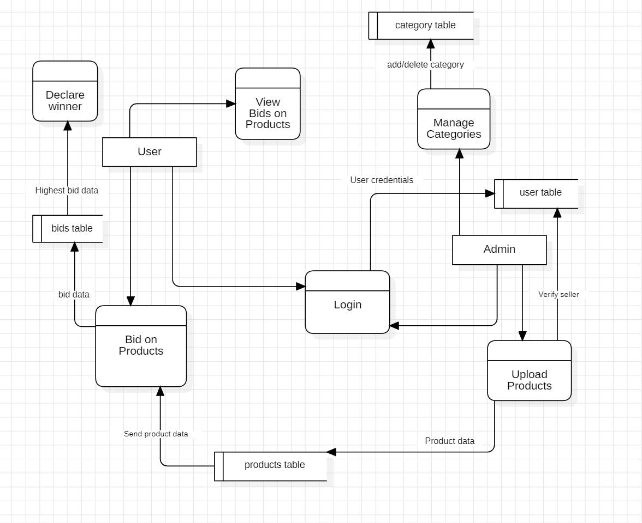

**4 . EXPERIMENTATION:**

**4.1 PRELIMINARY STUDIES:**

Preliminary studies are essential in the early stages of building a web application for an auction platform that sells baby products. These studies provide a foundational understanding of the market, user needs, and technical requirements. Here are key areas to focus on during preliminary studies:

Market Research:

Identify the target audience and potential customers. Are you targeting parents, caregivers, or collectors of baby products?

Analyze the demand for baby products in the online auction market.

Investigate your competitors and their strengths and weaknesses.

Explore market trends and emerging opportunities in the baby product industry.

User Research:

Conduct surveys, interviews, or focus groups to gather insights from potential users. What are their preferences and pain points in buying baby products?

Understand the specific needs and concerns of parents and caregivers.

Identify the types of baby products that are in high demand and the price ranges users are comfortable with**.**

Technology Stack Research:

Investigate the technology stack needed for your web application, including programming languages, databases, hosting, and security measures.Explore e-commerce platforms, content management systems, and auction-specific software that may streamline development**.**

Platform Features:

Determine the core features your auction platform should include, such as user registration,product listings, bidding, payment processing, and messaging.Explore additional features that could set your platform apart, like a user-friendly search system or seller verification.

Sourcing and Quality Control:

Research how to onboard sellers and ensure the quality and safety of products listed on your platform.Develop guidelines for product listings and quality checks.

Marketing and Branding Strategy:

Begin planning your marketing strategy to build brand awareness.Consider content marketing, social media campaigns, and advertising channels to attract users.

**4.2 RESULTS & ANALYSIS :**

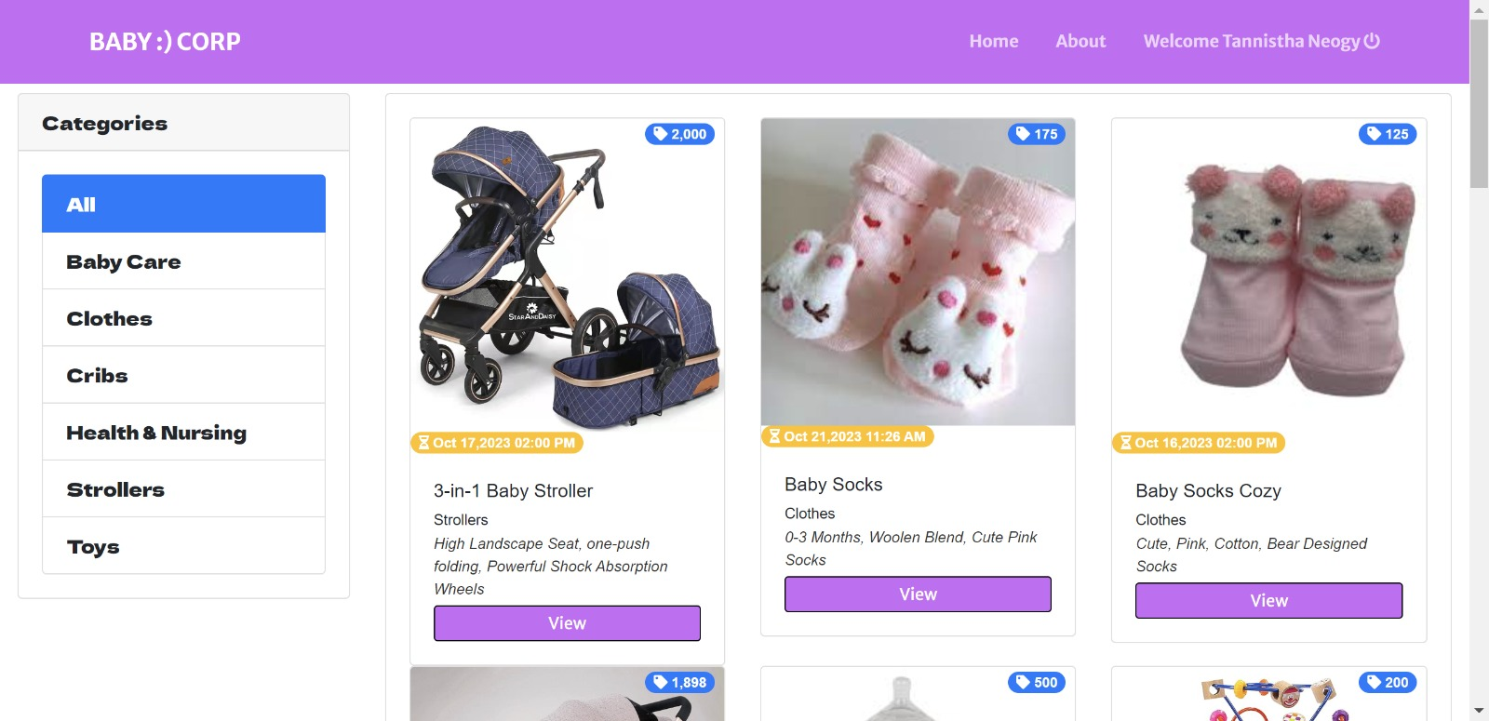

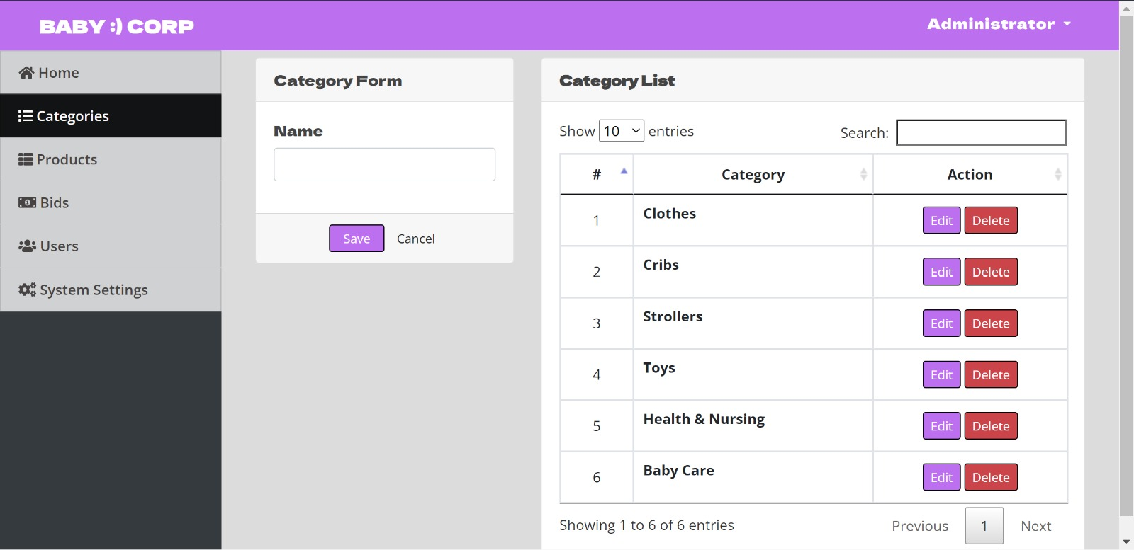



"BabyCorp" demonstrates a strategic approach to e-commerce by honing in on the specific needs of parents and caregivers. The platform's niche focus on baby products speaks directly to the challenges and considerations that come with parenting, offering a tailored solution. Its user-centric design emphasizes convenience and safety, providing a reliable marketplace for users. Notably, the project's dedication to quality and compliance with safety standards instills trust in buyers and sellers alike. Additionally, the platform's community-building efforts foster a sense of belonging among caregivers, recognizing the importance of shared experiences. With a clear focus on future growth and potential diversification, "BabyCorp" shows promise in its ability to evolve with the evolving needs of parents and caregivers, solidifying its position as an innovative force in the online auction platform landscape for baby products.

**5. CONCLUSION :**

**5.1 INFERENCE :**

The "BabyCorp" project, an online auction platform for baby products, holds several notable inferences and implications based on its objectives, execution, and potential impact:

Addressing a Niche Market: The project's focus on baby products targets a specific, yet significant, niche within the e-commerce landscape. This niche addresses the needs of parents, caregivers, and families, offering a dedicated platform for the purchase and sale of baby-related items.

User-Centric Approach: "BabyCorp" is inherently user-centric, prioritizing the convenience and safety of parents and caregivers. By simplifying the process of buying and selling baby products and adhering to rigorous quality and safety standards, it offers a platform that aligns closely with the needs and concerns of its target audience.

Safety and Regulatory Compliance: The project places a strong emphasis on adhering to safety standards and regulatory compliance for baby products. This commitment ensures that products listed on the platform meet the highest safety and quality criteria, which is paramount when dealing with items for infants and toddlers.

Business Opportunities: "BabyCorp" creates business opportunities for both established retailers and emerging entrepreneurs in the baby product industry. It serves as a marketplace where businesses can connect with a wide audience while providing a diverse range of products.

Innovation in E-Commerce: The project aims to push the boundaries of e-commerce, especially within the baby product industry. By leveraging technology and user-centric design, it introduces an innovative and user-friendly platform that combines the excitement of online auctions with the accessibility of the digital age.

Community Building: Beyond transactions, "BabyCorp" aspires to build a community of caregivers and parents. By encouraging engagement and sharing of experiences, it fosters a sense of belonging and support among its users, recognizing that parenting is a shared journey.

Trust and Reputation: Building trust is at the core of the project. By providing a secure and reliable platform for buying and selling baby products, "BabyCorp" aims to create a reputation as a trustworthy and reputable marketplace.

User Satisfaction and Well-Being: Ultimately, the project is driven by the desire to contribute to the well-being of infants and toddlers. By offering a platform that ensures access to high-quality and safe baby products, "BabyCorp" plays a role in providing children with the best possible start in life.

In conclusion, "BabyCorp" is a project that caters to the unique needs of parents and caregivers in the realm of e-commerce. Its inferences are deeply rooted in safety, user-centricity, community building, and the potential to foster business opportunities, all of which contribute to the well-being of children and the satisfaction of its users. It reflects an innovative approach to online commerce while maintaining a commitment to quality and trust.

**5.2 FUTURE SCOPE :**

The "BabyCorp" project, an online auction platform for baby products, holds significant potential for future expansion and development. Here are some avenues for future scope:

Product Diversification: Expand the range of baby products offered on the platform to cater to a broader spectrum of needs, including furniture, toys, educational materials, and more.Global Expansion: Consider entering international markets to reach a wider audience of parents and caregivers around the world, potentially by localizing the platform for different regions.Introduce New Features: Continuously innovate by adding features such as AI-driven product recommendations, virtual try-ons for clothing, or live bidding events to enhance user experience.Mobile Application Development: Develop a dedicated mobile application to cater to users who prefer shopping on mobile devices, providing a seamless and user-friendly experience.Subscription Services: Offer premium subscription plans for sellers, providing enhanced visibility, marketing tools, and analytics to boost their sales.Community Forums and Content Creation: Integrate community forums and user-generated content where parents can share experiences, tips, and recommendations related to parenting and baby products.Parenting Resources and Guides: Provide educational resources and guides on topics like baby care, child development, safety tips, and product recommendations to further assist parents and caregivers.Partnerships and Collaborations: Collaborate with baby product manufacturers, retailers, and influencers to offer exclusive deals, promotions, and curated product collections.AI-Driven Insights: Implement data analytics and artificial intelligence to gather insights on user behavior, popular products, and emerging trends to optimize the platform's offerings.Virtual Events and Webinars: Host virtual events, webinars, or live Q&A sessions with experts in the field of parenting, health, and child development to engage with the community.Personalized Shopping Experience: Utilize data-driven personalization to offer tailored product recommendations and content based on individual user preferences and behavior.Sustainability Initiatives: Introduce eco-friendly and sustainable product categories to cater to environmentally-conscious parents seeking greener alternatives.Incorporate AR/VR Technology: Implement augmented reality (AR) or virtual reality (VR) features to allow users to visualize products in their own spaces before making a purchase.Expand into Pre-Owned and Vintage Products: Create a dedicated section for pre-owned baby products, providing an eco-friendly and cost-effective option for parents.Offer Subscription Boxes: Curate and deliver customized baby product subscription boxes based on the specific needs and preferences of subscribers.

By exploring these future scope opportunities, "BabyCorp" can continue to evolve, meet the changing needs of its users, and remain at the forefront of the online auction platform for baby products industry. Staying adaptable and responsive to market trends and user feedback will be key to the project's long-term success and growth.